October Homework Packet

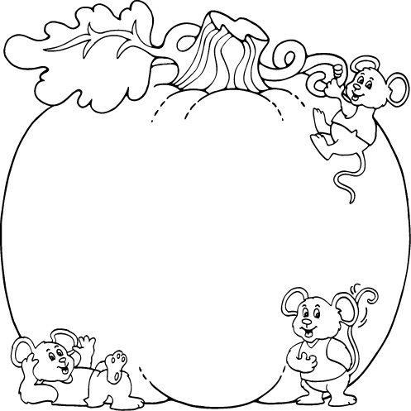



|  |  |  |  |  |
| --- | --- | --- | --- | --- |
| Student name: | | | | |
|  | Activity #1 | Activity #2 | Activity #3 | Activity #4 |
| Week 1  Sight Words | Practice writing the letters “H” and “h” 5 times each.  Practice counting to 40 | Draw/write two things that begin with the same sound as “baby”.  Color the leaves the correct color. | Practice writing the letters “I” and “i” 5 times each.  Practice a fire drill with your family. | Create a list of things you notice with your senses at home.  Count by 10’s to 100 |
| Week 2  Sight Words | Practice writing the letters “J” and “j” 5 times each  Cookie math: count the chocolate chips and write the number | Draw/write two things that begin with the same sound as “dog”.  Create a pattern by coloring the leaves. | Practice writing the letters “K” and “k” 5 times  Write numbers 0-20  Practice counting to 50 | Make a list of words that rhyme with man. (An adult may right the words).  Circle the group that has fewer. |
| Week 3  Sight Words | Practice writing the letters “L” and “l” 5 times each  Practice counting to 60 | Write the whole alphabet in lower case letters.  Draw what comes next in the pattern. | Practice writing the letters “M” and “m” 5 times each  Write numbers 0-20 | Write all your sight words with your favorite color  Create a pattern by coloring the pumpkins |
| Week 4  Sight Words | Practice writing the letters “N” and “n” 5 times each | Draw/write two things that begin with the same sound  as “fire”  Create your own pattern | Practice writing the letters “O” and “o” 5 times  Write your numbers to 20 | Write the sight words in the correct boxes.  Practice counting to 60 |
| Week 5  Sight Words | Practice writing the letters “P” and “p” | Draw a face on the pumpkin. Try to write a sentence about your pumpkin. | Practice writing the letters “Q” and “q”  Draw a picture of you in your Halloween costume. |  |
| H h | | | | |
| Draw/write two things that begin with the same sound as “baby”  Color the leaves the correct color  red  green  brown  orange  yellow  Pg32f.png  Pg32f.png  Pg32f.png  Pg32f.png  Pg32f.png | | | | |
| I i | | | | |
| Look around the house and write down different things that you natice with your senses.  Sight Smell Hearing  Taste Touch | | | | |
| Jj | | | | |
| Cookie Math | | | | |
| Draw/write two things that start with the same sound as “dog”.  Color the leaves to create a pattern.  Pg32c.pngPg32c.pngPg32c.pngPg32c.pngPg32c.pngPg32c.pngPg32c.pngPg32c.pngPg32c.png | | | | |
| Kk | | | | |
| Write your numbers 0-20   |  |  |  |  |  |  |  |  |  |  | | --- | --- | --- | --- | --- | --- | --- | --- | --- | --- | | 0 |  |  |  |  |  |  |  |  |  | |  |  |  |  |  |  |  |  |  |  | |  |  |  |  |  |  |  |  |  |  | | | | | |
| Make a list of words that rhyme with man. (An adult may right the words).  Circle the group that has fewer.  Pg20f.pngPg20f.pngPg20f.pngPg20f.pngPg20f.png  Pg25e.png  Pg25e.png  Pg20f.pngPg20f.pngPg20f.pngPg20f.pngPg20f.png  Pg25e.png | | | | |
| L l | | | | |
| Write the lower case letters of the alphabet | | | | |
| What comes next in the pattern: | | | | |
| Mm | | | | |
| |  |  |  |  |  |  |  |  |  |  | | --- | --- | --- | --- | --- | --- | --- | --- | --- | --- | | 0 |  |  |  |  |  |  |  |  |  | |  |  |  |  |  |  |  |  |  |  | |  |  |  |  |  |  |  |  |  |  |   Write your numbers to 20 | | | | |
| Write the sight words in your favorite color  the is my and for I like at to see  you it in was had | | | | |
| Color the pumpkins to create a patternusing two colors.  Pg27.pngPg27.pngPg27.pngPg27.pngPg27.pngPg27.pngPg27.pngPg27.pngPg27.pngPg27.png  Color the spiders to create a pattern, use three different colors.  Pg24b.pngPg24b.pngPg24b.pngPg24b.pngPg24b.pngPg24b.pngPg24b.pngPg24b.pngPg24b.png | | | | |
| Nn | | | | |
| Draw/write two things that start with the same sound as “fire”.  Create your own pattern. | | | | |
| Oo | | | | |
| Write your numbers to 20   |  |  |  |  |  |  |  |  |  |  | | --- | --- | --- | --- | --- | --- | --- | --- | --- | --- | | 0 |  |  |  |  |  |  |  |  |  | |  |  |  |  |  |  |  |  |  |  | |  |  |  |  |  |  |  |  |  |  | | | | | |
| Write your sight words in the correct boxes.  my and like you to | | | | |
| Pp | | | | |
| Draw a face on the pumpkin and write a sentence about it.  Pg24c.png | | | | |
| Qq | | | | |
| Draw a detailed picture of what you look like in your halloween costume. | | | | |